Longside School
Standards & Quality Report
2022 - 2023
&
School Improvement Planning
2023 – 2024

School Forward

We are pleased to present both our Standards and Quality Report for Session 2022- 2023 and our School Improvement plan for the current session 2023 -2024. This report forms part of our quality improvement framework and provides important information regarding our schools progress to date and identifies our next steps in school improvement.
Self-Evaluation for Self-Improvement is at the heart of our practice. We continue to develop our practice in making robust use of evidence as a basis for judgements regarding the impact of our work on our learners.
How are we doing?
How do we know?
What are we going to do now?
Looking inwards to analyse our work
Looking outwards to find out more about what is working well for others locally and nationally
Looking forwards to gauge what continuous improvement might look like in the longer term
At Longside School we continue to be committed to working closely with our community and all other stakeholders that support the education we provide. Together we are working hard to ensure all our pupils get the best possible start in life and are enabled and encouraged to maximize their potential.
We realise that within education things never stand still or stay the same. We continue to strive to meet the changes and challenges. Through this document we hope that you will get a sense of our developments, successes and areas for further growth.
John Imlah
Head Teacher

The School and its context
Longside Primary School is situated in the village of Longside and serves the catchment area of the village and the surrounding rural area. The school turns 18 years old in October 2023 and is a PPP (Public Private Partnership) building. The school is non-denominational. A number of pupils who live outwith the catchment area also attend the school.
The school building has eight classrooms, a General Purpose room, a large PE hall (where lunch is served from our “in house” kitchen) and administration accommodation. The school also has Early Years (3-4yrs) provision which comprises indoor and outdoor space. The main school has a sensory (Quiet) room, the nursery has a sensory area. Outside, there is a large tarmac play area and a large field area, as well as a wildlife garden, an area of outdoor play equipment and a quiet seated area. We are currently developing a wild area within the grounds to support learning and meet children’s sensory needs.
Longside School provides education for children aged 3 – 12. The current roll is 162 primary children and 43 pre-school children. The school has seven full time equivalent teaching staff and a non-teaching Head Teacher. The position of Principal Teacher for the Mintlaw CSN is held by Mrs. P. Musson who is based within Longside School. Mrs Musson has 2 management days (1.5 days for the school and 0.5 days for the cluster) and 3 teaching days. Mrs Musson has only just begun her work in this role (May 2023). Over time, the peripatetic Visiting Specialist model (for NCCT) has diminished and as the Drama teacher retires this year, only one specialist remains for MLPS. Additional Support for Learning staff come into school for two days and, through additional funding, we increased this to three days . Teaching staff are supported in class by Pupil Support Assistants. P.S.A.s also support pupils in the playground. We have an Early Years Senior Practitioner, an Early Years Lead Practitioner and a team of EYPs working in our pre-school setting. There is an Administrator and a Clerical Assistant. Cleaners and Janitorial staff are employed by RFM (Robertsons Facilities Management).

Community links are a valued part of school life. The Head Teacher is a member of the Community Council. The school maintains links with the Community Council and Garden, this year our Parent Council is collaborating with the Community on a summer event.
The school has an active and thriving Parent Council. Parents and Carers are encouraged to become involved in the work of the school through volunteering opportunities which have opened up again this year. There is an ethos of belonging and shared responsibility and leadership opportunities are particularly in evidence via School House Group Meetings, Pupil Parliament & Class Reps, Eco work and the Health promoting School groups. Many classes implement a ‘my responsibility’ approach where children are given particular roles.
School clubs (extra-curricular) have begun again this year and teachers currently offer football and Arts and Crafts.
The school operates its budget in line with Aberdeenshire Authority guidelines to support planned school improvements. In June 2011 the school and nursery received a positive report from HMIe.

On leaving Longside School, pupils transfer to Mintlaw Academy. A further ten primary schools (all in the Mintlaw Community Schools Network) transfer to Mintlaw Academy.

Creating an ethos of achievement is central to what we do in Longside School and we work hard to establish an environment in which all our pupils, staff and members of our community are able to fulfil their full potential and expectations. Staff and pupils enjoy working together in a high
Vision, Values and Aims

Vision Statement: “Learn, Achieve, Grow”

Our Agreed Core Values are consistent with SHANARRI:
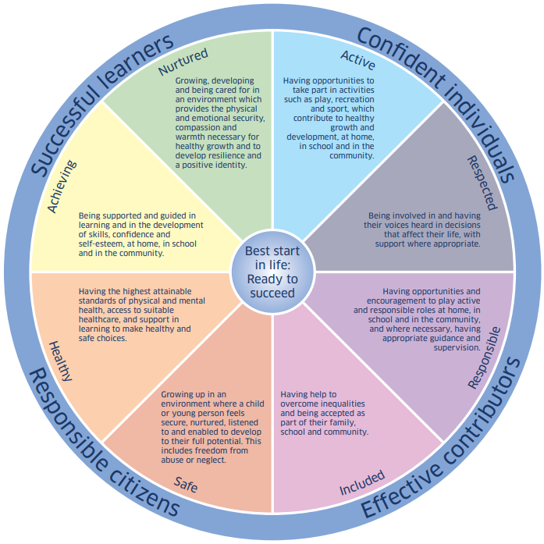
Safe
Healthy
Achieving
Nurtured
Active
Respected
Responsible
Included

The School’s aims are entirely consistent with the ambition of Curriculum for Excellence which is to develop young people who are:

Successful learners
With:
- enthusiasm and motivation for learning
- determination to reach high standards of achievement
- openness to new thinking and ideas

Confident individuals
With:
- self respect
- a sense of physical, mental and emotional wellbeing
- secure values and beliefs

Responsible citizens
With:
- respect for others
- commitment to participate responsibly in political, economic, social and cultural life

Effective contributors
With:
- an enterprising attitude
- resilience
- self-reliance

Impact of our developments
In this section we will outline the Targets we set last session and identify the progress we have made during session 2022-2023.
Key priority 2022-2022 | Key actions undertaken | Impact (achieved throughout 2022-2023)
Priority 1 : To improve:  The quality and consistency of learning, teaching and assessment across the school. | School’s assessment policy has been reviewed and slightly updated.  Staff worked collegiately to develop and implement a HQA for Numeracy which was evaluated by the team.  Staff attended high quality CLPL and a number of HQA exemplars are available for staff to refer to  P1 teachers across cluster developed baseline material for P1s (Numeracy)  In-Set time spent looking at ‘A Model for Great Teaching’ and a draft pledge (outlining what we agree are core elements of high quality L + T) has been prepared by staff (May 2023)  Moderation of Writing has been a focus, internally teachers shared work including some assessed pieces with a focus on how targets are set; HTs spent time looking at Writing across the cluster using the Moderation Cycle  Staff spent one Faculty Meeting looking at the detail of the Metaskills progression and discussing how it might be used going forward to support the design of L.I.s and S.C. | In most classes, some more ‘periodic’ and summative assessment is in evidence including use of PM Reading Benchmarking, GL material and a small amount of HQA was conducted in most classes. Alongside that PASS for H + W and ongoing use of SHANARRI assessments as necessary for specific pupils. SNSA and GL detail is scrutinised and next steps for learners identified and implemented.  Staff comment that they understand and can demonstrate what has been agreed within our L + T pledge (June 23).  Confidence in assessing Writing is relatively high and linked to our Writing Action Plan, there is a slight upward trend in overall attainment.  Some evidence of older skills progression evident within sampled lessons
Priority 2 : To improve:  Community sense of shared purpose including overall vision and drivers of school improvement work as well as developing aspects of the planned H & W programme (wellbeing major focus) | School V, V and Aims have been revised following consultation with stakeholders. Finalised and issued June 2023.  Promoting Positive Relationships Framework has also been consulted upon and slightly revised. All staff had an opportunity to feedback on this.  Continuing engagement with UNCRC articles through both class work and House Work leading to another recognition certificate (Unicef UK outright award 22-23)  School programmes for H & W have been further defined and included in StaffSharepoint XXX A continuing focus on Big Life Journal and SCARF as core resources. ALEC in to support aspects of H & W programme. Lots of material shared with parents for H & W including Substance Abuse material, online safety, RSHP programmes and content, ongoing focus on how the school responds to children with specific ASN and how parents can help within newsletters (ASC, ADHD, reluctant readers). Parents contributed to an exercise around our Anti-Bullying Statement.  Some more learning has been taking place out of doors over term 3 and 4.  Staff wellbeing surveys at two points (one for teachers in term 3 and one for all staff in term 4 to explore ideas/suggestions). | School values are well known and used and this session, stakeholders agreed that these were fitting (with one or two small adjustments following evaluation). SHANARRI work/UNCRC work and other H & W programmes reinforce the school values. Parent survey helped us re-define overarching aims to articulate with four capacities. Parents feel that children are encouraged to demonstrate respect. Children can talk confidently about SHANARRI and some can talk about values and how these are realised in our setting .  Parents have commented that they feel more part of the school – My highlights of the Year activity  Staff wellbeing activity and follow-up discussion (26.05.23) shows that staff feel there are good informal structures for peer support.
Priority 3 : To improve ……….Writing Attainment and develop pathways that ensure there is a sound rationale and programme in this curricular area | Curriculum Development time at start of year devoted to looking at whole-school approach to teaching Writing developed from North Lanarkshire model. Staff worked in stage groups and set themselves bespoke targets linked to the model that they felt would improve their practice.  Renewed focus on Enriching vocabulary approach and this has been a focus of attainment meetings. Staff were encouraged to set ambitious targets for Writing for their learners in Nov. A Writing Wall has been established to promote this aspect of the curriculum.  Terms 3 and 4 included CDT time to discuss targets set earlier in the year and to moderate Writing work. | All staff (including new staff who joined in Jan 23) now understand the Enriching Vocabulary approach and comment that this is well established in most classes. Staff comment that the taught language is actively being well used in literacy work and in context work.  Staff report confidence in assessing Writing and there is an improvement to the overall attainment picture
Nursery  QI 2.5: Family Learning | Family engagement: Engaging families in learning (focus on Hygge accreditation).  Nursery children, families and staff involved in changing the environment to reflect ‘home like’ features. New lunch time routine established to ensure children can choose independently.  Celebrating achievements: Children have a sense of achievement and successes are recorded and celebrated.  Parents and children encouraged to talk about personal achievements, at home and at nursery. Parents, children and staff contribute by adding leaf to Achievement Tree, detailing personal success stories. Re visit Tree, achievements updated termly. Leaf added to pupil profile.  Leadership and Management: Quality Assurance (focus on policies and procedures).  Targeted focus on priority policies. Child Protection, Missing Child (share with whole school), Provision of Food, Intimate Care, Management of Medication, Promoting Positive Relationships. Additional policies considered when specific situations present. | All staff have been proactive in implementing change to the environment. All staff responsible for an area of the setting, creating improvements based on children’s likes, suggestions based on the development of Hygge within the setting and family feedback. Family feedback include children explaining to parents what they like about the changes. Out of 25% of families who responded, all noted their child’s positive response, words included enjoys, loves, likes, better.  Most children are aware of the Achievement Tree and the aim of the Tree. Most children are happy to discuss personal achievements. Some explain their achievements to peers, and some discuss their peers' achievements in a positive manner.  Policies have been created or reviewed on a priority bases. Policy calendar established. Staff signposted to any new information within policies. Parents/families signposted to facebook to view any new or updated policies. Policies and procedures within same document, ensuring policy is concise and procedures easy to follow.

How good is our leadership and approach to improvement?

QI 1.3 Leadership of change
Developing a shared vision, values and aims relevant to the school and its community
Strategic planning for continuous improvement
Implementing improvement and change
Relevant NIF priority: All
Relevant NIF driver(s): School leadership, Teacher professionalism, School improvement
Level of quality for core QI: 3
(HGIOS?4/HGIOELC? 1-6 scale)
How well are you doing?
What’s working well for your learners?
- Stakeholders work closely together to consider priorities taking school attainment data into account and other available information such as FSM info. and PASS (H & W) info.
- Faculty Meetings/CDT time clearly articulate with Improvement Plans
- Longside school has a curriculum rationale and framework in place that allows for staff to incorporate elements of particular local relevance / current affairs. The curriculum framework is shared with all stakeholders periodically. It allows for some flexibility in organising learning and teachers often comment that the three-year prog is effective and allows for good collegiate discussion (see end of year teacher planning meetings )
- There is a very positive ethos at Longside School, the vision and values are well established and used across the school, the aims have been revised this year via a wider consultation and will now centre around the ambition of the 4 capacities
- The school continues to embed the UNCRC articles through weekly focus articles, House Work and curriculum development work. For the second year we were awarded a UNICEF UK OUTRIGHT award for the good work we have done across the whole school on promoting children’s good health
- Pupil leadership is in evidence at various levels but particularly through work of House groups and Pupil Parliament; Sports leaders also helped plan for an Athletics event
- A comprehensive parent evaluation has been completed and an analysis of the results prepared and shared with all which will inform some aspects of our Improvement Planning
- A comprehensive P4-P7 survey has been completed in May 23 and results are to be shared
- Some partners have supported our work – ALEC for H & W, SSPCA assemblies on child safety, links with Peterhead Community Centre for Swimming lessons (P5), parental support as well as Cycling Officer to enable delivery of Bikeability, Active Schools have worked with staff to enable us to offer Football and Netball
- Staff in school work closely and support one another, there is a culture of sharing CLPL and discussing pedagogical approaches; good use has been made of shared planning time for moderation
- Regular SLT meetings help define roles and responsibilities
- HT worked with other local HTs on Moderation of Writing Activity
- Teachers have worked to complete a draft pledge on Learning and Teaching linked to A Model for Great Teaching
- Attainment is regularly scrutinised and a tracker is maintained for all children (including pre-school children); teachers discuss attainment at three points in the year with SLT and plan teaching based on analysis following tracking and assessment periods (SNSA and CfE)
- Teaching staff audit themes linked to HGIOS 4 across the school year per 3-year rolling programme; we also look at other schools’ evaluations to help us identify next steps
- PSAs now line managed by PT who offers occasional team meetings which will always include an aspect of School Improvement activity as well as PPP for individuals linking to school and national priorities
- A QA calendar exists and is adhered to and targets met – quality of learning and teaching remains central to this activity and all staff receive feedback from SLT and peers over the course of the year
- CLPL has been accessed to articulate with school improvement priorities – staff attended sessions on L & T toolkit, high quality input from Mark Burns and Shirley Clarke on pedagogy as well as Digital Skills training via LoveLearning Team
- Some pupil voice is evident through day to day classroom negotiations, contributions to LIs and SCs, class forums, Pupil Parliament and pupil questionnaires e.g. PASS, SHANARRI self-assessments, P4 – P7 survey
- Regular Newsletters remind parents of our aims/improvement priorities and tackle issues of inclusion and diversity – many have had an ASN focus helping parents to understand the presentation of specific ASN and how the school can respond positively
- Parent Council also looked at and supported a revision to the school’s ‘Promoting Positive Behaviour Policy’ (now the Promoting Positive Relationships Policy)
- Some staff continue to take on leading roles with aspects of school life – e.g. UNCRC, Digital strategy, Maths Mastery/Numeracy
- Staff in school know children well and are very much aware of the socio- economic context of the community and other factors. All staff continue to strive to ensure they are supportive and understanding of all families.
- Professional Review and Development for teachers (PRD) and Employee Annual Review (now PPP) of all staff conducted annually (or bi-ennially) taking into account personal development needs and school improvement priorities with agreed targets to improve outcomes.
- Cluster HTs work closely on strategic planning and deployment of staffing resources
- Current thinking and research about quality in early learning and childcare underpins continuous improvements in our setting. Researching and developing a ‘Hygge’ approach to our thinking and environment has led to significant changes at lunch time and snack time. Feedback reflects parental approval and interest in new developments.
- RAG Action Plan 2 August 2023 - Creation of ELC Curriculum Rationale taking into consideration Hygge changes to setting and parents views from Sample Pre Inspection questionnaire and other various feedback documentation.

How do you know?
What evidence do you have of positive impact on learners?
- Children access a varied and broad curriculum and a good range of learning experiences.
- Children access wider achievement clubs either directly or indirectly by school promotion – e.g. School Arts and Crafts Club, School Netball Club, School Football Club, other wider Active Schools activities; success is celebrated on Facebook and in assemblies
- Children’s learning has been enriched by the contributions of partners named above
- Bigger projects and wider opportunities – e.g. Coronation Activity and Coronation Family Picnic, Sports Day, Swimming for P5, Residential trip for P7, Bikeability for P6, school excursions to enrich curriculum experiences
- P4-P7 pupil survey indicates that children generally enjoy their learning most of the time
- We have provided families with various tools to support home-learning such as Core Numeracy Mastery pamphlets, How to contribute to developing your child’s vocabulary, emerging literacy and how to support this at home, EPS suite of material to support families with a range of ideas on e.g. Growth Mindset, Self-regulation, etc., regular homework, parent literature linked to RSHP resource, sharing exemplars of Health and Wellbeing content at Parents’ Nights
- School values are celebrated through displays and are the themes for pupil assemblies which are developed by the pupils
- SHANARRI is well-understood and children are conversant with these
- Staff and parent focus groups are ongoing; anti-bullying statement has been reviewed by interested parents as a focus group, V, V and Aims was released for consultation to all and finalised via Parent Council in June 2023
- Very good use of SeeSaw until December 2022 (which parents commented was an excellent tool for sharing learning);
- Regular opportunities for parents to come in and share learning – assemblies, curriculum footloose focus, Open Night
- Parent survey indicates that parents feel children are safe and respected in school
- There is an ethos of professional engagement and collegiate working from all staff. Annual calendar of staff meetings with focus areas linked to the school improvement plan. There are regular opportunities for all staff to engage with QI documentation to review practice and plan next steps. The school has a clear three-year cycle to ensure all aspects of HGIOS is considered when evaluating and improving practice.
- Teaching staff have a range of leadership opportunities such as Technologies, STEM, and Literacy
- PPP/PDRS/QA and Improvement Planning documents articulate well; staff access CPD linked to school IP, national priorities and areas of special interest
- Nursery - Feedback from parents, staff and children highlight the positive impact the changes to lunch time routine has made. Children who were not always keen on eating what was on their plates, are happy to choose independently from a buffet style serving table. Children taking ownership for own choices. Children are discussing the positive lunch time changes with families at home.
- RAG Action Plan 2 August 2023 - Creation of ELC Curriculum Rationale taking into consideration promoting independence in learners and involvement from families.

What are you going to do now?
What are your improvement priorities in this area?
- Parent and pupil survey results evident in Imp Plan for next session – although pupils feel listened to they do not always feel their opinions are valued
- Look at offering further parent curriculum sessions as requested via consultation early this session – e.g. Maths Mastery
- Interested staff to take on areas of development and some responsibility for Imp Planning
- Continue with changes, review and reflect at start of new term. Find ways to encourage children’s voice when evaluating changes.

How good is the quality of care and education we offer?

QI 2.3 Learning, teaching and assessment
Learning and engagement
Quality of teaching
Effective use of assessment
Planning, tracking and monitoring
Relevant NIF priority: All
Relevant NIF driver(s): Teacher professionalism, School leadership, Parental engagement, Assessment of children’s progress
Level of quality for core QI: 3
(HGIOS?4/HGIOELC? 1-6 scale)
How well are you doing?
What’s working well for your learners?
- There is a positive learning climate in the classes and across the school
- There has been a continuing focus on high quality questioning and focus on high quality LIs and SCs; we have also identified the activation of prior learning as an area for further work following In-Set training
- A combination of RIC frameworks, Aberdeenshire frameworks and national benchmarks are used to inform planning of learning and assessment and identify appropriate next steps thus ensuring progression in learning across the school. Staff plan collegiately when this is possible to support moderation of practice and ensure a shared understanding of expected standards.
- A carefully considered and well-balanced programme of learning is delivered across the school
- Almost all pupils engage well with learning experiences, are eager to learn, motivated and involved; fluid groupings offer challenge
- Pupils have some opportunities to lead learning and share their ideas, what they want to learn and resources they will use.
- Many pupils can articulate what they are learning and why and know what they need to do in order to become successful. Some can relate what they are learning to the wider world.
- We continue to offer children opportunities to demonstrate ownership and independence with their learning
- This session there has been more evidence of self/peer assessment opportunities through our Writing priority
- Learning intentions and success criteria are evident for core areas of learning. Sometimes children are included in co-constructing these.
- Almost all staff make effective use of questioning during learning and teaching experiences extending learning as appropriate.
- Where possible, paired and groupwork within classes is evident
- Almost all learning experiences are planned to match pupils needs/abilities and agreed frameworks are used to inform teachers’ planning
- A good blend of effective formative assessment approaches are in evidence; some summative assessment is in place and an assessment policy has been completed
- Staff know their pupils very well and liaise with SLT and ASL through a range of processes to improve their experiences
- All teaching staff have confidence in using a wide range of assessment data including standardised assessment results to plan for next steps
- Three periods are identified for tracking progress and there are regular opportunities to reflect on the learning journey through planning and attainment meetings
- Children feel valued, as a result, they are successful, confident and taking responsibility for their own learning. The introduction of an Achievement Tree helps children focus on what they want to achieve and how they can make steps towards their goals. During Stay and Play sessions, families can contribute to the Achievement Tree by holding discussions with their children and nursery staff, then adding a leaf to the tree.
- RAG Action Plan 1 August 2023 – Focus on Numeracy, link to Achievement Tree by having focus for Tree. Children challenge themselves, add wishes and aims to Achievement Tree. Build in 4 capacities to Tree – “I can” statements with numeracy focus.

How do you know?
What evidence do you have of positive impact on learners?
- Most children achieve national expected levels
- PEF is used to support staff to plan interventions to overcome any barriers faced and develop relationships to improve learning. This year, additional funding has allowed additional ASL teacher time for Numeracy where there is good evidence of progress for all learners; Time to Talk (facilitated by PSA) remains available to support pupils pastoral needs and is well used- parents and pupils comment on the efficacy of this resource
- Very good ASL teaching support in evidence with three periods of feedback to parents regarding progress and next steps; good evidence of progress for almost all of these pupils exists
- Additional Planning for pupils is meticulous and evaluated periodically and demonstrates good understanding of need and SMART targets where required – ASL planning, IEPs, PEEPs, Child’s Plan minutes, IBP/RA etc.
- Pupils are developing knowledge, and many older children can speak about the skills they are acquiring in a more general, wider - application sense
- Most children work confidently within fluid groups and this is supporting them to be able to identify their next steps
- Three tracking periods alongside attainment/planning reviews are conducted
- There is a calendar for assessment (PASS/SNSA/ Emerging Literacy- P1) and some other standardised assessment is completed when staff are looking for further information to support planning for learners; analysis and next steps are carefully recorded
- Assessment maintains a focus within staff development time and some small updates have been made to our policy
- Consideration of trends in data are used appropriately to inform future improvement planning
- A Wider-Achievements database exists where children’s extra-curricular experiences are tracked; this is used as a platform to identify further opportunities for pupils
- This session we created a Writing Wall to celebrate children’s Writing; Facebook is also well used by teachers and staff to share pupil work and showcase learning
- Children will happily discuss their Achievement Tree leaf with peers and other adults. Children know what they want to Achieve in Numeracy.

What are you going to do now?
What are your improvement priorities in this area?
Support pupils to understand their core learning targets through assessment and profiling approaches use the new tool – Just2Easy
Develop further understanding around four types of assessment (HQA, Ongoing assessment, periodic assessment and standardised assessment) to support moderation and teacher judgement (use of WestPartnership resource)
Promotion of pupil voice via activating prior learning and thought-shower processes (KWL); use of early and end of block assessment
Review how well skills are embedded in our day to day planning to L & T; re-enage with Ed Scotland material on Meta-Skills
Develop moderation via cluster stage group meetings – 2 areas of curriculum over session
- Support children further by re-visiting achievements and planning challenges together.

How good are we at improving outcomes for all our learners?

QI 3.1 Ensuring wellbeing, equality and inclusion
Wellbeing
Fulfilment of statutory duties
Inclusion and equality
Relevant NIF priority: All
Relevant NIF driver(s): Assessment of children’s progress, School improvement, Performance information
Level of quality for core QI: 4
(HGIOS?4/HGIOELC? 1-6 scale)

How well are you doing?
What’s working well for your learners?
- A continuing focus on SHANARRI this year means children are conversant and more able to self-assess against indicators
- Young people feel safe at school
- Young people feel that staff want them to do their best
- Through work across the four contexts, healthy messages are consistently and persistently shared
- School meets the requirement for 2 hours of P.E. and encourages other good lifestyle choices through Clubs
- In many classes, children have specific roles of responsibility; there are whole-school roles such as House Captains and Vice-Captains, Sports Captains and Pupil Parliament Representatives
- Attendance is promoted in a variety of ways, exclusion rates are extremely low
- Our young people report that physical education and activity are important to the school
- A slightly adjusted policy has been relaunched- promoting positive relationships policy which highlights that everyone has a role
- Restorative justice underpins our work and is well implemented with children increasingly encouraged to engage in the restorative process with minimal adult intervention
- A school anti-bullying statement has been reviewed (Nov 2022) by interested parents and the theme of bullying has been tackled across the school at two points this year
- Very good programmes are in place to support inclusive and progressive ideology (SCARF, Big Life Journal, ALEC, UNCRC material)
- SSPCA material used in school to remind children of key safety messages
- A calendar of whole-school events/Parental Engagement events supports an overall cohesion and positive ethos
- Staff have a very good knowledge of learners, families and their community. A supportive ethos exists across the school for all pupils and children feel safe and cared for
- Most core areas of learning are well-differentiated
- At two points in the year a whole-school needs analysis is conducted and children are identified for particular support
- ASL support is good – this includes a consultation facility for staff, advice and guidance through Needs Analysis activity, specific assessment to support identification of specific learning difficulties and targeted individual and small group work
- Good quality information is shared between ASL and teaching staff
- Staff are clear on the policies and procedures around child protection. Staff are vigilant and prompt in highlighting concerns and responding to issues
- Processes are in place to support the development of specific children’s plans where required – Pupil Wellbeing Webs/‘My Views About School’ are used to support the process of recording pupil voice
- PASS (Pupil Attitudes to Self and School) is used to support the process of identifying children who may require additional support
- Diversity is celebrated within programmes of work (e.g. SCARF as well as RSHP programme) and as part of the school values – e.g. assemblies about inclusion/diversity
- A good range of universal supports are available in all classes (WOW boxes) as well as special nurture areas (class areas and Quiet Room)
- PEF is used to support processes such as ‘Time to Talk’
- Clear procedures are in place to identify, assess and plan for pupils with additional support needs. IEPs, Managing Accessibility Plans (MAPs), and risk assessments are in place for individual pupils as appropriate and are developed with pupils, as appropriate, and parents to improve outcomes for learners.
- Where required, pupils have chronologies in place. Pastoral notes are used on SEEMIS to support this.
- At 3 points, attainment/planning meetings with a member of SLT and individual class teachers have a focus on pupils’ needs and discussion re targeted interventions. This supports the deployment of staff including Pupil Support Assistants (PSA) and ASL staff.
- Transition programmes and activities are in place for Early Years/Primary/Secondary to ensure the well-being of pupils. Tracking detail, end of year progress information and additional information about learning is shared and a handover conversation takes place.
- Transitions from class to class are carefully considered and, where required, some ‘enhanced planning’ exists – e.g. pupils with ASC are offered extra visits to new class with parents
- Esgoi and now iSgoil in place for ‘interrupted’ learners
- School has promoted EPS Family Nurture material at several junctures and used the material to support particular parents where situations have arisen e.g. bereavement, anxiety
- We have promoted Kooth material in a robust way and directed parents to this resource in a universal and targeted way
- Parents of children with more complex ASN are offered early ‘settling-in’ informal
- Children have been identified for CRH and EH support via CPM and other processes – e.g. some access IPT support, one child accesses School Counsellor, Nature/Nurture Practitioner works with two children
- The promotion of wellbeing for all our children and their families underpins everything we do and is based on mutual respect, honesty and trust. Policies are updated and reviewed on a priority basis to ensure the safety and respect of our families and service
- The promotion of wellbeing for all our children and their families underpins everything we do and is based on mutual respect, honesty and trust. Policies are updated based on priorities for the setting and our families. Policies documents include procedures to ensure all staff are aware of clear protocol. Policies are shared on rotation through facebook. Excerpts from policies are shared with staff at meetings or through email.
- RAG Action Plan 1 August 2023 – Focus on cascading information to parents on how planning cycle works. Gather feedback on understanding of and family contribution to ELC planning cycle.
How do you know?
What evidence do you have of positive impact on learners?
- RRSA certificate acknowledging work on Children’s Rights
- Certificate from SSPCA re. use of child safety material
- Pupil surveys identify key strengths – e.g. pupils feel staff want them to do their best and feel respected by and listened to by staff
- Most young people feel that wider achievements are acknowledged and celebrated
- Many children have accessed an after-school club at one point
- Families comment through evaluation processes that children are well cared for and feel safe
- Most families feel they can approach the school with issues/concerns
- Annual update of GIRFEC/Child Protection training carried out.
- A nurturing and restorative culture exists and plans additional plans are in place as required- IBP/RA
- Staff complete requisite data protection, equalities and diversity training as provided by local authority
- PASS (Pupil Attitudes to Self and School) continues to be used annually to identify and support individuals
- Where there were concerns linked to PASS, wellbeing webs were completed and analysed to support planning; these were re-administered and almost all showed improvement in one or more areas
- Almost all teaching staff comment that they have all the tools required for delivering a comprehensive H & W programme and that the greater emphasis on SHANARRI has helped clarify the school’s wider strategy
- Good data to demonstrate the value added through targeted ASL work
- Meticulous detail is maintained on children’s additional support needs and background on teacher ASL lists
- Outside agencies such as school nurse, doctor, CAMHS, SW and SandLT contribute to Child’s Plans; EPS has observed and supported plans for specific pupils
- Sensory support provides ongoing guidance and support for a staff member
- Child’s Planning meetings - staff are extremely pro-active and solution focused and contribute salient and supportive ideas
- Relevant pupils receive bespoke support from IPT, Nature/Nurture Practitioner, Counsellor, etc.
- A universal passport project is in place for transition
- I-Sgoil now in place for one pupil
- Specific in-house transition meetings take place for some children as required
- P7 – S1 has a well-considered calendar of events with a good blend of virtual and real-life opportunities
- CLD and PWW support have supported particular pupils preparing for P7 – S1 transition
- A clear and well-understood plan was devised and followed for sharing information about pupils across the school as they move to new classes
- Improvements and updates to policies ensure the safety and wellbeing needs of all our families are being met.

What are you going to do now?
What are your improvement priorities in this area?
- Pupil voice could be improved within CPM process
- Embed new VV and Aims as well as Promoting Positive Relationships policy
- More opportunities for whole school to explore multi-faith issues, challenge religious intolerance and develop a clearer understanding of fairness (some children say issues are not always dealt with fairly)
- Audit of WOW (ways of working) material and top-up as required
- Continue to work on policy documents, encourage children’s contribution to policy creation and review by devising mind map system prior to making any changes to policy documents. Photocopy and add to back of policy document.
- Continue to include families in decision making and evaluation of service.

QI 3.2 Raising attainment and achievement
Attainment in literacy and numeracy
Attainment over time
Overall quality of learners’ achievement
Equity for all learners
Relevant NIF priority: All
Relevant NIF driver(s): Assessment of children’s progress, School improvement, Performance information
Level of quality for core QI: 3
(HGIOS?4/HGIOELC? 1-6 scale)

How well are you doing?
What’s working well for your learners?
- School tracking systems for CfE and achievements are well established
- Careful interrogation of pupil levels takes place at least twice in the year
- SNSA results at P4 and P7 are fair/good and most pupils perform at average or just above average banding (given the required support)
- Ambitious CfE targets are now being set in all core areas as well as discussions around necessary interventions for this
- Our tracking systems account for pupils who require additional support/adjusted programmes
- Staff make good use of agreed tools for planning learning through Frameworks and endorsed programmes of work e.g. SCARF and RSHP; this, along with national benchmarks, supports a good understanding of expected standards in Literacy and Numeracy
- Staff participated in Cluster moderation activity for Writing
- Pupil Equity Funding has been used to allow for more tailored support from PSAs linked to personal planning (ASL etc.)
- Through PASS, it is clear that children feel involved in their learning
- A number of different documents and newsletters have been issued to support parents’ understanding of the curriculum e.g. Early Years Lit and Num programmes, 3-year rolling curriculum, Vocabulary Enrichment material, Core Numeracy Targets, Preview and homework and Relationships and Sexual Health slides
- We effectively promote learning in a skilful way. We understand how young children develop early language skills and mathematical thinking. We apply this knowledge in our approach. Children’s next steps are collated, and an audit of the environment allows staff to add resources that support or challenge needs of individual children.
- Kay Macdonald tracking system allows us to see most children are making good progress in Numeracy and Literacy.
- Learners who required support or learners who have significant ASN are making appropriate progress through adjusted planning tools.
- RAG Action Plan 1 – Focus on Numeracy, see plan.

How do you know?
What evidence do you have of positive impact on learners?
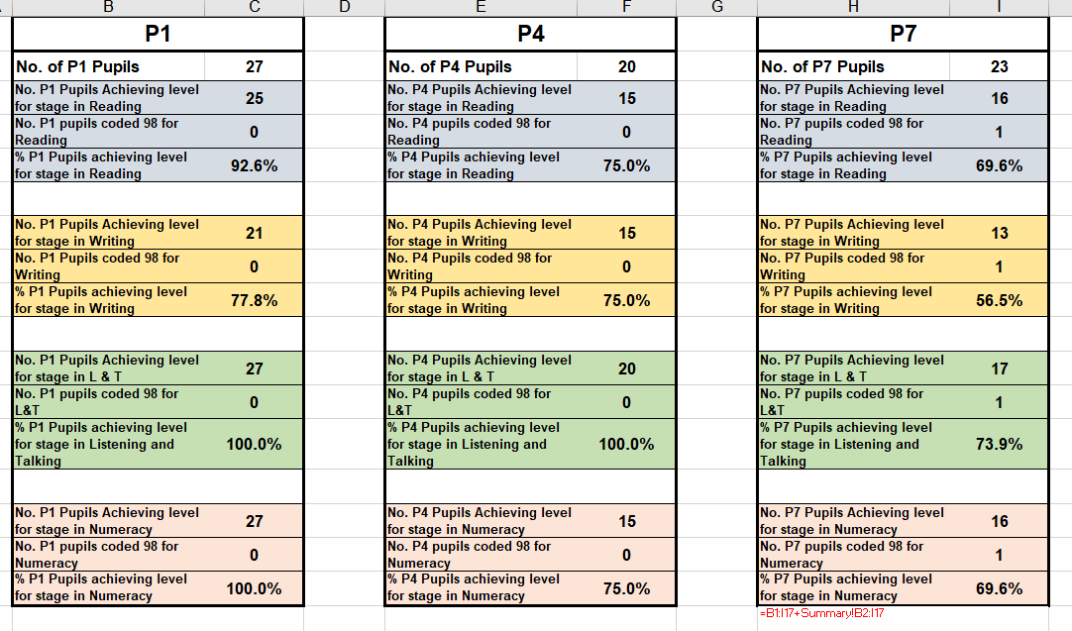
Although writing CfE Writing levels may appear low, ten of twenty three children have an identification of dyslexia and one pupil has an IEP, SNSA Writing results were fair for this age group with most falling into average bands or above
- IEP targets have been met and new targets consistently set throughout the year.
- Support plans in place have been reviewed with families and new targets set.
- Tracker system (Kay McDonald) has been evaluated (see RAG section
- See RAG section; Learning, Teaching and Assessment – Progress in Communication, early language, mathematics, health and wellbeing.

What are you going to do now?
What are your improvement priorities in this area?
Development of approaches to Meta-skills and embedding into AiFL strategies
Wider Achievements Board re-established
Continue with Writing Wall and embed improvements through vocab enrichment and rigorous assessment
Audit of WOW(ways of working) material and new resources purchased matched to specific pupil needs

PEF 2023-2024

Identified gap  Linked to barriers identified through analysis of data | Access to additional/tailored support for children with CPMs/IBPs/IEPs (PSA time)  Access to a facility to promote good mental wellbeing ‘Time to Talk’ (offered by PSA)
Expenditure | £8, 950
Expected outcomes  What change do you want to see for learners? How much change? Who are the target group? By when | Targets are met on CPMs and IEPs
Impact Measurements  How will you know the change is an improvement? | Refer to targets on CPMs and IEPs

Capacity for improvement

School and Nursery staff are fully committed to the principle of continuous improvement. We wish to provide the very best for every child in our care. In this task, we are increasingly advised by performance data, such as pupil attainment data, so we can see clearly ‘what’ we need to improve.
We will continue to look inwards, outwards and forwards to prepare and equip our young people for their future. We will continue to work in partnership with parents, health professionals, and others to ‘get it right’ for every child.

Action plan 1
National Improvement Framework Priorities | HGIOS and ELCC  1.1 Self-evaluation for self-improvement  1.2 Leadership for learning  1.3 Leadership of change  1.4 Leadership and management of staff/ practitioners  1.5 Management of resources to promote equity  2.1 Safeguarding and child protection  2.2 Curriculum  2.3 Learning teaching and assessment  2.4 Personalised support  2.5 Family learning  2.6 Transitions  2.7 Partnerships  3.1 Improving/ ensuring wellbeing, equality and inclusion  Specific to HGIOS 4  3.2 Raising attainment and achievement  3.3 Increasing creativity and employability  Specific to HGIOELC  3.2 Securing children’s progress  3.3 Developing creativity and skills for life |  |  | Aberdeenshire Priorities:  1. Improving learning, teaching and assessment.  2. Partnership working to raise attainment.  3. Developing leadership at all levels.  4 Improvement through self-evaluation.
- Placing the human rights and needs of every child and young person at the centre of education
- Improvement in children and young people’s health and wellbeing
- Closing the attainment gap between the most and least disadvantaged children and young people
- Improvement in skills and sustained, positive school-leaver destinations for all young people
- Improvement in attainment, particularly literacy and numeracy.
Key drivers of improvement
School and ELC leadership

Teacher and practitioner professionalism

Parental/carer involvement and engagement

Curriculum and Assessment

School and ELC improvement

Performance Information

Priority 1: To improve learning and teaching through the creative use of digital technologies. | Data/evidence informing priority: Staff completed a Clarify Canvas on the school’s digital estate; Hayward review indicates the national ambition for a more digitally savvy and resilient society
Key actions | By whom | When? | How will we evaluate impact?  (Measurements of success) |  | Progress
 |  |  |  |  | On Track
 |  |  |  |  | Behind Schedule
 |  |  |  |  | Not Achieved
PLANNING  Minibeast used to track progress and 3 intervals over the year, including providing a predicted level at end of year.  Document ‘What Digital Learning Might Look Like’ used for reference and ideas by teachers. Digital Leader to share this document again for the upcoming academic year.  Staff registered with Barefoot Computing for refencing lesson plans and activities to support the Computing Science Planning.  Staff kept informed on CLPL offered from LoveLearning team. Apple teacher and Google Educator training opportunities shared. Space allocated on noticeboard.  Online Safety Policy completed and distributed.  Undertake 360 SafeScotland review to identify areas for improvement.  Safer Schools app launch to school community; teachers/PSAs/pupils/parents. School website updated to support this.  TEACHING  Just2easy resource used to support teaching. Training sourced for teachers via the Just2easy website. Parents Portal Letter reissued to parents so to access parental features on app.  Safer Schools app installed on all mobile devices and teachers accessing tools. Re issue login details. Arrange/plan launch date to the school.  Teachers/PSAs training on core support platforms, including Microsoft Teams, Google Classroom and j2e. PSA training for using support features on iPads.  LEARNING  Individual class devices set up and used to support learners with additional support needs. Devices used by identified users to support home/school learning.  Possible digital learning inputs from outside sources; technology days at Mintlaw Academy for senior pupils, visits/input from students at RGU in Aberdeen.  ASSESSMENT  Use of digital tools for formative assessment; Kahoot, Plickers, Padlet, Microsoft forms, Google forms etc.  Teacher questionnaire for feedback.  Digital profiling used; just2easy, My World of Work, etc.  Standardised assessment SNSA.  Use of GL assessments to show areas of strengths and/or weaknesses/validate teachers’ judgements/ identify areas of support. GL Health and Wellbeing assessment used twice yearly. | Teachers  Teachers  Teachers/Digital Leader  Teachers/PSAs  Digital Leader/ Online Safety Group  Digital Leader  SMT/ Digital Leader  All  Digital Leader/ Teachers/ PSAs  Digital Leader  SMT/ Academy  Teachers/Digital Leader  Teachers  Teachers/SMT  Teachers/SMT | Ongoing  Term 1  Term 1  Ongoing/monthly  Term 2  Term 3  Term 2  Term 1  Term 2  TBC  Term 1  TBC  Term 1 onwards  Term 1 onwards  Ongoing  Term 1 onwards | Clear indication of child’s attainment level in all areas for summative assessment and reports.  Staff confidence in using a variety of digital platforms, apps and resources.  Staff confidence in planning and delivering updated computing teaching and learning.  Digital leader regularly shares training opportunities with staff. Staff advised to join Aberdeenshire CLPL Teams for Love Learning online training.  360 SafeScotland document complete and checked with other members of the school including management, teaching staff, support staff, pupils and parental representation.  All school members understand the areas identified as requiring attention.  Majority of school community accessing app and communication between school and parents established.  Staff/pupils/parents accessing teaching and learning materials. Increase in the uptake on homework/ preview activities.  Teachers using the resources and support materials from the Teacher’s Toolkit and the resources available on the app for senior pupils. Communication with parents improved and more parents and families accessing the school website.  Teaching and support staff using a greater variety of digital resources and embedding digital literacy in the classroom. Teachers/PSAs confident in supporting children with additional needs.  Pupils confident to use devices independently, select appropriate digital tools to support learning; dictation tools, coloured background, text size etc. Homework activity uptake increased.  Greater scope of skills covered. Pupils confident and enthusiastic in their learning.  Teachers’ confidence in using digital tools to support prior knowledge and assessment creatively.  Regular update of learning. Teachers’ use platforms to provide timely and regular feedback to pupils and to share with parents.  All teacher predictions and supported and updated accordingly.  Teachers can identify more targeted needs of an individual and can access support in a more timely manner. |  | ON TRACK  ON TRACK  ON TRACK  ON TRACK  BEHIND SCHEDULE  BEHIND SCHEDULE  BEHIND SCHEDULE  ON TRACK  BEHIND SCHEDULE  BEHIND SCHEDULE  ON TRACK  BEHIND SCHEDULE  ON TRACK  ON TRACK  ON TRACK  ON TRACK

Action plan 2
National Improvement Framework Priorities |  | HGIOS and ELCC  1.1 Self-evaluation for self-improvement  1.2 Leadership for learning  1.3 Leadership of change  1.4 Leadership and management of staff/ practitioners  1.5 Management of resources to promote equity  2.1 Safeguarding and child protection  2.2 Curriculum  2.3 Learning teaching and assessment  2.4 Personalised support  2.5 Family learning  2.6 Transitions  2.7 Partnerships  3.1 Improving/ ensuring wellbeing, equality and inclusion  Specific to HGIOS 4  3.2 Raising attainment and achievement  3.3 Increasing creativity and employability  Specific to HGIOELC  3.2 Securing children’s progress  3.3 Developing creativity and skills for life |  |  | Aberdeenshire Priorities:  1. Improving learning, teaching and assessment.  2. Partnership working to raise attainment.  3. Developing leadership at all levels.  4 Improvement through self-evaluation.
- Placing the human rights and needs of every child and young person at the centre of education
- Improvement in children and young people’s health and wellbeing
- Closing the attainment gap between the most and least disadvantaged children and young people
- Improvement in skills and sustained, positive school-leaver destinations for all young people
- Improvement in attainment, particularly literacy and numeracy.
Key drivers of improvement
School and ELC leadership

Teacher and practitioner professionalism

Parental/carer involvement and engagement

Curriculum and Assessment

School and ELC improvement

Performance Information

Priority 2 : To improve our universal approaches to inclusion | Data/evidence informing priority: Local Authority data, HT and parent surveys and stakeholder focus groups (information provided to us by EPS service)
Key actions | By whom |  | When? | How will we evaluate impact?  (Measurements of success) |  | Progress
 |  |  |  |  |  | On Track
 |  |  |  |  |  | Behind Schedule
 |  |  |  |  |  | Not Achieved
Train the Trainer training to be attended as introduction to the CIRCLE Framework – after training take time to consider implications for our setting and what possible actions may be moving forward  Training for Teachers and Pupil Support Staff as introduction to the CIRCLE Framework – allow time for staff to familiarise themselves with the framework – develop a cohesive understanding of the resource  Ask staff to look at the CIRCLE Inclusive Classroom Scale (CICS) and identify how it could help with inclusion in school / their classroom – each identify one area they could develop/take further; PSAs and EY – other areas of the school used by learners  Introduce the CIRCLE Participation Scale (CPS) to staff along with the Skills, Supports and Strategies Section – allow staff to work through the CPS and the Skills, Supports and Strategies section to familiarise themselves with it and then ask them to choose a specific child who may be struggling with their participation in school in some way – allow them to work through the CPS and choose possible supports and strategies to try to see if they help the child with their participation  Revisit the supports and strategies put in place for the specific child and see if they are having an impact and decide on the way forward  Agree a set of standards / expectations in terms of how classes / the wider school should be presented to ensure as inclusive an environment as possible for all learners, eg.  - Complete CICS at the start of each school year and revisit throughout the session at the start of Term 3 and Term 4 and make any necessary changes  - Complete the CPS when appropriate for any child who may be struggling to engage in their learning before looking for external support beyond the classroom  Taking any CICS / CPS along to any meetings about specific learners who may be struggling to engage with their learning and discussing any strategies / changes already made and tried | HT, PT and EYSP |  | Sep 23  Nov 23  Nov 23  Mar 24  End of session | School community is aware of resource  Staff working with children are informed about and understand how the resource can be used to support inclusive practice  Evidence of strategies being used specifically for a small number of identified children with ASN (initially) and some evidence emerging of increased participation levels  Evidence of increased universal pupil participation through use of CICS  Evidence of improved learning environment through use of CICS  Evidence reflected through thematic audit by teaching staff as well as focussed audit of 3.1

Action plan 3
National Improvement Framework Priorities |  | HGIOS and ELCC  1.1 Self-evaluation for self-improvement  1.2 Leadership for learning  1.3 Leadership of change  1.4 Leadership and management of staff/ practitioners  1.5 Management of resources to promote equity  2.1 Safeguarding and child protection  2.2 Curriculum  2.3 Learning teaching and assessment  2.4 Personalised support  2.5 Family learning  2.6 Transitions  2.7 Partnerships  3.1 Improving/ ensuring wellbeing, equality and inclusion  Specific to HGIOS 4  3.2 Raising attainment and achievement  3.3 Increasing creativity and employability  Specific to HGIOELC  3.2 Securing children’s progress  3.3 Developing creativity and skills for life |  |  | Aberdeenshire Priorities:  1. Improving learning, teaching and assessment.  2. Partnership working to raise attainment.  3. Developing leadership at all levels.  4 Improvement through self-evaluation.
- Placing the human rights and needs of every child and young person at the centre of education
- Improvement in children and young people’s health and wellbeing
- Closing the attainment gap between the most and least disadvantaged children and young people
- Improvement in skills and sustained, positive school-leaver destinations for all young people
- Improvement in attainment, particularly literacy and numeracy.
Key drivers of improvement
School and ELC leadership

Teacher and practitioner professionalism

Parental/carer involvement and engagement

Curriculum and Assessment

School and ELC improvement

Performance Information

Priority 3 : To develop our Play approaches in P1 & 2 | Data/evidence informing priority: Tracking meetings, play audit, assessments, teachers’ professional judgements
Key actions | By whom |  | When? | How will we evaluate impact?  (Measurements of success) |  | Progress
 |  |  |  |  |  | On Track
 |  |  |  |  |  | Behind Schedule
 |  |  |  |  |  | Not Achieved
Primary 1 and Primary 2-Year 1  Research ideas for development of learning spaces in Term 1.Throughout the session, staff to engage in recommended professional reading about Play Approaches. Extracts from the following publications will be used:  “Interacting or Interfering: Improving interactions in the early years” – Julie Fisher  “Moving on to Key Stage 1: Improving Transition into Primary School” – Julie Fisher  “Starting From the Child: Teaching and Learning in the Foundation Stage” – Julie Fisher  “Can I Go and Play Now” – Greg Bottrill  “School and the Magic of Children” – Greg Bottrill  “Early Education Practice” – Tina Bruce  “Planning in the Moment With Young Children” – Anna Ephgrave  “Effective Transition into Year One” – Alistair Bryce-Clegg  “Play is the Way” – Upstart Scotland  Following key practitioners on Twitter – Leana Sweaton, Catriona Gill, Lynn Taylor https://scottisheducatorsconnect.com/play-based-learning-in-the-primary-school/ | PT/Teaching staff/PSA |  | Throughout the year  Aug  Nov  Feb | -Training and knowledge of child development, and understanding of how to support children’s learning.-Learning through continuous professional development.  -Staff will have a clearer understanding of the rationale behind Play Pedagogy and its importance  -Staff will develop their understanding of the Pedagogy of Play and what this may look like in their class.  -P1 and P2 staff will be supported to develop classrooms effectively and transition will be more seamless from nursery.  -Collegiate time set aside for CLPL / Professional Reading to begin to explore how these approaches can be implemented in their classrooms  Audits to be completed to record progress and barriers to improve our practices.  Term 1- Learning Environment  Term 3- Curriculum |  | On going
Visits to other schools in the cluster and beyond to share best practices around play to develop ideas for the development of learning spaces. | Ongoing through the year |  | P1 and P2 Teachers | Through the sharing of practice / visiting colleague’s rooms, staff will develop their ideas for development of learning spaces |  | On going
Complete an audit of current play based learning in P1 and P2 using a Play Audit based on “in the Moment Planning” to inform us of areas of interest and development. | Term 1 September 2023 |  | P1 and P2 Teachers | -Evaluation of learning environment would be complete  -Learning environment would be rich in opportunities to engage with concepts and foster skills for learning such as creativity and problem solving.  -P1 and P2 staff will be supported to develop classrooms effectively and transition will be more seamless from nursery. |  | On track
Create a list of desired resources to integrate children’s play experiences with curricular learning. | Term 2 Nov 2023 |  | P1/2 teachers | -Learning environment would be rich in opportunities to engage with concepts and foster skills for learning such as creativity and problem solving.  -Resource list for environment to be completed in line with the progression suggestions /IDL links |  | On track
P1-2 staff to plan learning spaces /classroom spaces and what a progression in those spaces would look like | Term 2  Nov 2023 |  | P1 and P2 Teachers | -Play progression would be complete and shared with all P1/2 teachers  -Breadth and Challenge to be mapped out.  -P1 and P2 staff will be supported to develop classrooms effectively and transition will be more seamless from nursery. |  | On track
Develop the skill of stepping back and noticing what the children are involved in.  Observe the child’s learning giving time for staff to capture what the child’s thinking prior to interacting with them and then developing a plan for building or extending the child’s thinking | Term 3  Feb |  | P1 and P2 Teachers | Supporting high quality interactions by the creation of a tool that supports observations and next steps in each child’s learning  Continuing to value children’s contributions to their own learning and offering opportunities for children to take ownership of their learning |  | Ongoing-discussions with Nursery Jan 2024 regarding online tool  Trialling paper tool –created Jan 2024
 | Term 4 |  |  | Embed the use of the progression and evaluate the effectiveness of the tool  Revisit resources list

Action plan 4
National Improvement Framework Priorities |  | HGIOS and ELCC  1.1 Self-evaluation for self-improvement  1.2 Leadership for learning  1.3 Leadership of change  1.4 Leadership and management of staff/ practitioners  1.5 Management of resources to promote equity  2.1 Safeguarding and child protection  2.2 Curriculum  2.3 Learning teaching and assessment  2.4 Personalised support  2.5 Family learning  2.6 Transitions  2.7 Partnerships  3.1 Improving/ ensuring wellbeing, equality and inclusion  Specific to HGIOS 4  3.2 Raising attainment and achievement  3.3 Increasing creativity and employability  Specific to HGIOELC  3.2 Securing children’s progress  3.3 Developing creativity and skills for life |  |  | Aberdeenshire Priorities:  1. Improving learning, teaching and assessment.  2. Partnership working to raise attainment.  3. Developing leadership at all levels.  4 Improvement through self-evaluation.
- Placing the human rights and needs of every child and young person at the centre of education
- Improvement in children and young people’s health and wellbeing
- Closing the attainment gap between the most and least disadvantaged children and young people
- Improvement in skills and sustained, positive school-leaver destinations for all young people
- Improvement in attainment, particularly literacy and numeracy.
Key drivers of improvement
School and ELC leadership

Teacher and practitioner professionalism

Parental/carer involvement and engagement

Curriculum and Assessment

School and ELC improvement

Performance Information
Priority 4 : To embed our teaching and learning pledge/V,V and Aims and improve approaches to assessment | Data/evidence informing priority: staff indicate some desire to develop a more comprehensive assessment calendar with types and amount of reliable assessment more clearly defined
Key actions | By whom |  | When? | How will we evaluate impact?  (Measurements of success) |  | Progress
 |  |  |  |  |  | On Track
 |  |  |  |  |  | Behind Schedule
 |  |  |  |  |  | Not Achieved
Review L & T pledge at start of session with all staff and develop a tool with teacher input for lesson observation and peer observation that articulates with this  SLT develop teacher planning and attainment review tools to articulate with pledge and assessment policy  Faculty to agree on content of assessment folio – refer to current assessment policy which requires further definition of HQA, ongoing, periodic and standardised assessment  Nov In-Set Revisit Mark Burns input and link to school L & T pledge; review material from last session; define what evidence should exist for establishing pupils’ prior knowledge  V,V and Aims (June 23) – develop staff skill in giving these currency. Look at acknowledgement/Rewards systems linked to Values and Aims. Make substantial use of language of SHANARRI and 4 capacities within communications – Newsletters, Assemblies, announcements, etc. Promote use of  Update curriculum rationale | Teachers and SLT  Teachers and SLT  Teachers and SLT  Teachers  Whole school community including pupil groups |  | Term 1  Term 1  Terms 1 and 2  Term 2  Terms 1 – 4  Term 4 | Increased confidence and understanding of our definition of High Quality Learning and Teaching  Evidence within thematic HGIOS evaluations as well as evaluations of 2.3  Individual folios contain evidence of assessment in core areas of learning and support teacher judgements  Updated assessment policy that staff are familiar with  Good evidence of ‘value added’ through start and end of topic assessment as well as good evidence of KWL  School community is familiar with Values and Aims  Curriculum rationale reflects aspects of play pedagogy as well as revised approaches to proportionate assessment

School Achievements
Session 2022/23

Curriculum Areas and Subjects
- Classes sharing their learning through class assemblies - one in-house and one online using School Facebook page
- Christmas Show-each class (P1-P7) contributed
- Sharing our three-year curriculum plan with parents
- P1 parents invited to attend Early Literacy/ Numeracy workshops (term 1) - online PowerPoint presentations with voice over added to Longside School website for access
- Weekly “Time to Talk” sessions to promote wellbeing - PSA supported
- Extensive use of See Saw until Dec to share children’s learning and progress (Just 2 Easy to be introduced next session)
- Sharing material with parents – Emerging Literacy material, Enriching Vocabulary, Core Numeracy Targets, 3-year context planner, etc.
- Curriculum Workshops – new P1 parents
- School shared RSHP programmes, ALEC material and videos, detail about RSPCC content
- Sharing of class work through posts on Longside School Facebook page throughout the year as well as on Seesaw
- Termly Footloose Sessions for parents to visit- children sharing their learning
- Nursery – share photos on the Early Years Facebook page termly
- Stay and Play sessions in nursery – Termly – sharing children’s profiles/Learning Journey sheets with parents
- Sharing Learning Journey sheets with nursery parents, phone call or face-to-face per term
- Sharing WOW moments on Marvellous Me app in nursery
- ALEC caravan visit, visits from (People who help us)
  - Childsmile – Alison Bruce (HWB)
  - Police – PC Hislop
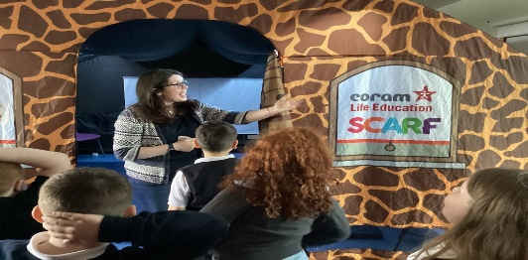
- Transition visit from secondary PE teacher to work with P7s
- Bruce House raised funds to Twin Toilets in Malawi
- Student in school as part of BP training programme

Opportunities for Personal Achievement
- P7 Leavers’ Assembly - parents invited in, June 23
- House captains/vices were chosen along with JRSOs
- Wider successes of House Group – Walk and Litter Pick Up, RRSA Award, production of school magazine, etc.
- Pupil Wider Achievements records maintained
- Weekly House Point updates - with termly House winners receiving extra outdoor time (popcorn/ juice) Overall House winners (end of year) visit to Cinema
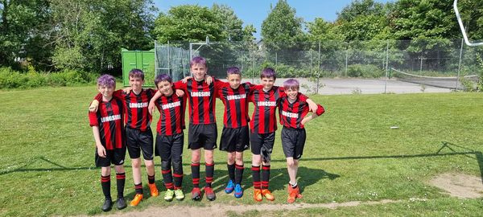
- Class assemblies – x2/class- one via Facebook and the other in school- linked to school values
- Participation in our Sports day- races and potted sports
- School Clubs- Netball, Arts and Crafts and Football

- Junior Road Safety officers shared safety stories termly with younger children and collected data for the annual “Hands Up” survey as to how we all travel to and from school
- Pupils awarded House Points and Headteacher awards for ongoing effort
- Writing Wall linked to school Improvement Plan
- Artwork entered to New Pitsligo and Fetter angus Arts Festivals
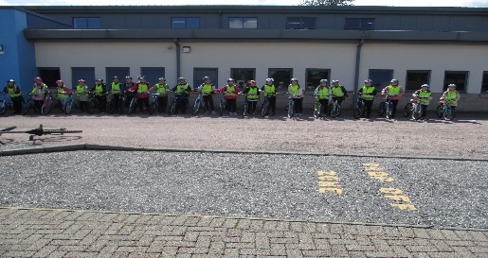
- Participation in the Buchan Area Athletics- P4-7
- Bikeability/Cycling in P5/6

- P7 attended Loch Insh residential trip
- Playground Mediator Training (P5s)
- P7 Fiver Challenge – raised £400
- Rotary Quiz – P7 came 3rd place
- Nursery – Achievement Tree
- Children individually accessing own Learning profile folder (in nursery)
- RSPCC Award

Interdisciplinary Learning
- All classes performed their Christmas Concert in school
- All classes performing x2 assemblies throughout the year- shared x1 on Facebook/ other in house
- EYS involved in the Child smile Brush bus Initiative
- Involvement with Longside Community Council to maintain the community garden- weeding of beds, planting of vegetables in raised beds
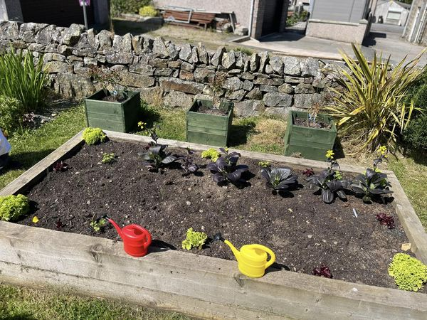
- High Quality Assessments
- P7 transition days/activities- June 2023
- Baking pancakes for Shrove’s Tuesday/ Easter cakes/ IDL topic work/ bread making- harvest
- P7 – Loch Insh Trip
- World Book Day
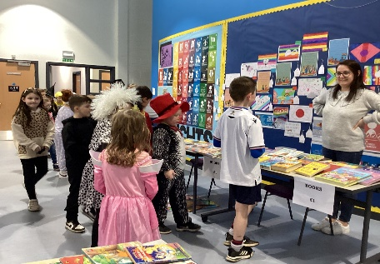
- Share a Pencil Day- P1-7. Global Education Awareness Day
- P1 received Bookbag bags as part of Scottish Book Trust; P2 and P3 received Read, Write and Count bags
- Active Schools- programme of classes available posted on School Facebook page
- Visitors into school to talk to children linked to SHANARRI indicators being introduced
- Burns Ceilidh- all classes participated in dancing, singing, recital of poems- parents invited in to join
- All P1-7 classes using Seesaw to document learning for all children and as a tool for Preview homework. Nurseries use Marvellous Me, and staff meet with parents to discuss learning termly
- Family Picnic – Scavenger Hunt

- P1 Coronation Assembly

Ethos and Life of the School
- School Clubs – Football, Netball, Arts and Crafts
- Many children hold particular roles/responsibilities within their own classes
- Ongoing posts on our Longside School Facebook information page for parents/ carers sharing information regarding- Longside Tennis Club, “On the Ball” football coaching, Dynamos Cricket
- Groupcall messages/ information sharing for parents/ carers
- All parents invited in to a “Meet the Teacher” introduction at start of term 1 and a Parent/Carer Calendar of events issued at start of year including Open afternoons/evenings, concerts, etc.
- Fund raising for various charities- Here is our Relay for Life photo
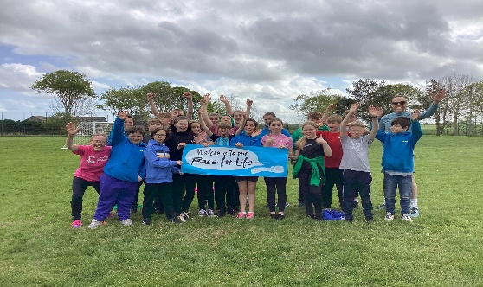
- Contributions from end of month dress down days- proceeds to Parent Council who have helped the school in numerous ways this session
- Textile collections- proceeds from the collections go to school funds
- Celebrating our school 17th birthday- cakes donated by PC
- Revised policies and procedures – Vision, Values and Aims, Promoting Positive Relationships Framework
- Supported Red Nose Day (£117.72), Children in Need (£400), British Legion Poppy Appeal and poppy laying ceremony at Longside Cemetery (P7)

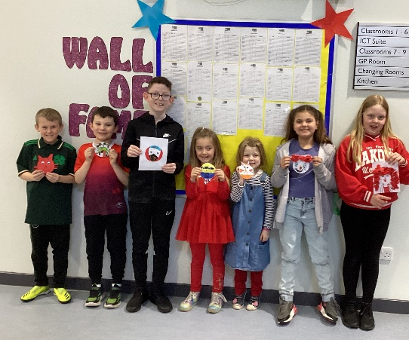
- Nursery- Stay and Play sessions for new entrants
- Community Christmas Tree decorating at the Churches

- Early Years celebrating coronation of King May 2023. PC donated our party food

- P6 Buddies for new P1 pupils

