Longside School
Vision, Values and Aims & Curriculum Rationale

(Refer also to Assessment Policy May 2022)
Draft Nov 2022

Vision, Values and Aims

Vision Statement: “Learn, Achieve, Succeed”

Agreed Values: Respect, Care, Trust, Fairness

Aims
We will have:
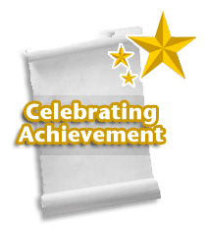
- the highest aspirations for all our learners and a climate of celebrating achievement

- a broad range and balance of discrete curriculum experiences as well as carefully considered IDL experiences
- a clear progression of experiences to develop skills

- a vibrant, enjoyable and challenging learning environment

- a culture that encourages creative and innovative approaches

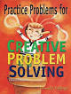

- a curriculum that promotes critical thinking and problem solving as an essential lifelong skill

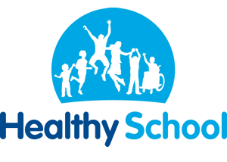
- a solution-focussed approach that empowers everyone to become resilient, resourceful and respectful

Developed with pupils, parents and staff in March 2015

Early Years and Childcare Aims
Vision statement: “Learn, Achieve, Succeed”
Agreed Values: Respect, Care, Trust, Fairness
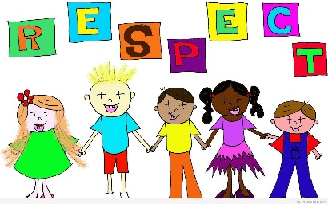
Be friendly and helpful towards each other.

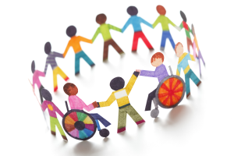

Being thoughtful and caring for one another.

Trust one another and try your best and share your achievements.

Everyone is treated equally in a non- judgemental way.

Early Years Aims prepared Aug 2016

Longside School Ethos
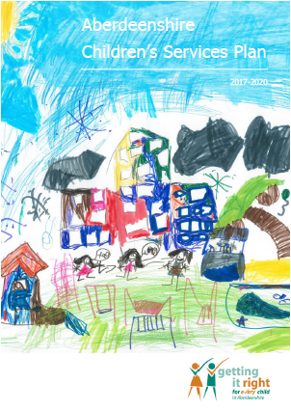
Getting It Right for Every Child (GIRFEC) is the national policy approach in Scotland which aims to support the wellbeing of all children and young people, by offering the right help, at the right time, from the right people. Certain aspects of this policy have been placed in law by the Children and Young People (Scotland) Act 2014.
Aberdeenshire’s schools play a key part in delivery of Aberdeenshire’s Children’s Services Plan.

Its vision is that:
‘Our commitment to Aberdeenshire’s children and young people, is to provide them with the right support, in the right place, at the right time.
In helping them reach their individual potential and goals, we will work together to make Aberdeenshire the best place in Scotland to grow up’
You can find out more about our Children’s Services Plan at:
http://www.girfec-aberdeenshire.org/who-we-are/our-childrens-services-plan/

Wellbeing
Wellbeing of children and young people sits at the heart of the Getting it Right for Every Child approach. Eight Wellbeing Indicators below outline our ambition for all learners at Longside School. Our school community is conversant with these indicators:
- S afe
- H ealthy
- A chieving
- N urtured
- A ctive
- R espected
- R esponsible
- I ncluded

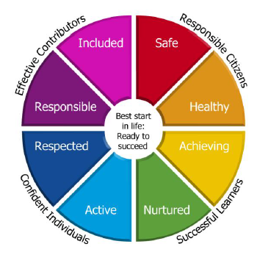
The Getting It Right approach means we will work in partnership with children, young people and their parent/carer(s) and we want every child at our school to feel happy, safe and supported to fulfil their potential.

Children’s Rights
The Children and Young People (Scotland) Act 2014 included new law to help make sure children’s rights are promoted across Scotland. Children and young people’s rights and participation are promoted in lots of different ways by schools in Aberdeenshire.
This means we:
- Raise awareness of Children’s Rights, and how rights can be accessed
- Provide opportunities for children and young people to get involved in decision-making
- Make sure children and young people’s views influence how we develop services
- Support children and young people to express their views (where needed)
- Listen to children and young people’s views on what we do well, and what we could do differently
Aberdeenshire Council has endorsed a Children and Young People’s Charter. You can find out more about Children’s Rights and opportunities for participation at:
http://www.girfec-aberdeenshire.org/home/children-and-young-people/
See also UNCRC
UN Convention on the Rights of the Child - UNICEF UK

Longside School Curriculum Rationale
Our Vision Statement : “Learn, Achieve, Succeed”
International Education
Developing Global Citizens
Use of expertise – parents, grandparents, local business etc
Build curriculum links - CfE opens the doors to creative, innovative and practical learning.
Build links with external agencies – key players in realising objectives.
FUN

Creative

Outdoors

Active

Cooperative

Collaborative

Experiential
Transformative

Engaging
Pupil-directed

challenging
Empowering

Pupil-centred

Olympic &
Commonwealth Games
Scotland’s Culture
Links with
Learners in France
It’s about HOW you teach it...
Our Values: Respect, Care, Trust, Fairness

At Longside School we have developed a curriculum based on the tenets of CfE and Aberdeenshire’s own 3-18 Curriculum Policy. Our vision and values are enshrined in our curriculum. Our children are provided with learning opportunities that recognise and celebrate their uniqueness, develop their full potential, allow them to fulfil their aspirations within and beyond the school gates and prepare them to meet the challenges of the 21st century. We aim to deliver excellence in learning and teaching and expect all learners to be actively engaged in their own learning.
At every level, an ethos of respect coupled with high aspirations and ambition for all our learners is promoted and attainment, achievement and participation are recognised and celebrated.
At Longside School, one of the primary missions of our curriculum structure is to engage all children in innovative, powerful learning experiences that will allow them to have a voice as effective contributors and to become both critical thinkers, and life-long learners. In order to achieve this goal, our pupils will have the opportunity to develop an authentic understanding of how the skills and knowledge they learn about in school are connected to everyday life in their community. Therefore, learning experiences will be meaningful and relevant, and education will strive towards equipping our learners with the knowledge and skills necessary to become responsible adults of the future to meet the challenges of our ever changing society. We all have a role in supporting our pupils to discover new ways to meet the needs of the present without compromising the needs of future generations. Our curriculum recognises the need to support personal development and empowerment so that each child within our care is able to develop as a healthy, balanced, resilient, self-confident individual and fulfil their educational potential.
Central to our curriculum’s design is the desire to develop four capacities in our youngsters – Successful Learners, Responsible Citizens, Effective Contributors and Confident Individuals. Our Curriculum is delivered through the four contexts of CfE – Life and Ethos of the school as a community, Curriculum Areas and Subjects, Inter-disciplinary Learning and Opportunities for Personal Achievement. Planned learning is informed by the seven design principles – Challenge and enjoyment, Breadth, Progression, Depth, Personalisation and Choice, Coherence and Relevance.
Skills Development
Skills are developed through an ‘I can’ approach, across all years with the delivery of Experiences and Outcomes. The development of skills is essential to learning and supports our pupils to become successful learners, confident individuals, responsible citizens and effective contributors. The skills and attributes which our pupils develop will provide them with a sound basis for their development as lifelong learners in their adult, social and working lives, enabling them to reach their full potential. Our curriculum aims to foster the development of key skills and recently we have begun to look at the meta-skills progression framework:
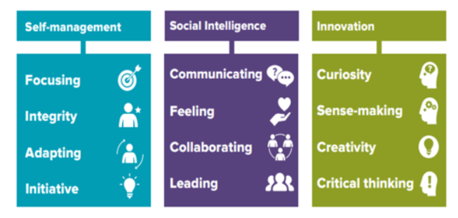
meta-skills-progression-framework-final.pdf (skillsdevelopmentscotland.co.uk)
Learning and Teaching
The success of our curriculum is through the delivery of high-quality learning and teaching. This is at the heart of our work and the use of a variety of teaching methodologies is an essential feature of our curriculum. A wide range of teaching strategies is implemented by all staff, where approaches to learning and assessment are varied and pupil-centred. Assessment Is for Learning techniques, direct teaching, self and peer assessment, Co-operative Learning, individual and group work, text-based work and practical work, the use of IT to support learning, outdoor learning, global citizenship, educational visits and visiting speakers are examples of approaches and methodologies designed to actively engage our pupils in their learning. In addition, occasionally we use summative assessment to assist ongoing tracking of progress.
There is a focus to continually support the professional development of our staff in the field of learning and teaching which involves colleagues sharing practice, within the school, the cluster and beyond by engaging in high-quality CLPL (such as SSERC training for STEM subjects), leading to further reflection of practice, incorporating new ways of engaging and supporting our learners. Formal and informal observation, survey results, attainment analysis and feedback are considered to promote improvement.

The Four Contexts for learning explained

1.The Ethos and life of the school as a community
Our curriculum offers a broad range of learning experiences for our pupils, where the children, and increasingly relevant partners, contribute to planning themes and topics in order to make learning meaningful. Our pupils are encouraged to contribute to the school community at every stage, where they have opportunities to lead their own learning and be instrumental in bringing about change and improvement. Shared values are communicated and promoted through Assemblies, Committees, Pupil discussions and through Personal and Social Education. A wide variety of opportunities take place regularly throughout the year to develop responsibility and promote good citizenship and leadership- Pupil Buddy Systems, Peer-Mediator systems, Pupil Parliament, House Work covering themes of Sustainability, UNCRC Rights, Health Promotion and School Magazine and Play Leader Work.

2. Curriculum Areas and Subjects
The period of education from pre-school to the end of S3 has the particular purpose of providing each young person in Scotland with a broad general education. At Longside all our learners will experience a Broad General Education which will include all of the experiences and outcomes across all 8 curriculum areas, progressing through the Levels, as far as this is consistent with their learning needs and prior achievements. We have agreed pathways for Literacy (e.g. we follow the North Lanarkshire programme) and Numeracy (using Northern Alliance Framework as a driver) and agreed programmes for Health and Wellbeing (including SCARF material and Big Life Journal package). We have an ongoing focus on SHANARRI and often bring partners in to enhance this programme. The remaining 5 curricular areas feature within our 3-year curriculum context plan. Experiences and Outcomes in these 5 areas are met by learners at Early, First and Second level.

3. Inter-disciplinary Learning (IDL)
Inter-disciplinary Learning (IDL) is a key feature of Curriculum for Excellence, which enhances the curriculum and is a feature of our contextualised planning (revised session 2019-20). It allows for learning beyond subject boundaries, cross curricular topics and standard programmes and places an emphasis on the process of learning and not on the subject area (often through the development of a key ‘Big Question’). We aim to give pupils opportunities to use knowledge and skills in transferable ways, ergo making connections across aspects of learning. We are also beginning to use some holistic assessment where children are required to generalise learning and use learning in a new context. This will become a feature of our new assessment statement.

Personalisation and Choice - As our pupils progress through their levels there will be opportunities for personalisation and choice in relation to their learning. Allowing our pupils to make informed choices about their learning encourages and motivates them to become successful learners. Personalisation and choice takes many forms including opportunities to identify their preferred lines of enquiry within an agreed framework; it also relates to how pupils will learn through active learning, through different activities offered within lessons and to the challenge relating to a learning outcome such as an IDL ‘Big Question’. There will also be opportunities for choice as to how pupils will demonstrate learning through making, saying, writing or doing, offering a range of assessment approaches.

Opportunities for personal achievement
There are many opportunities in school for personal achievement and we celebrate success in many ways using digital tools where possible – e.g. Facebook to share galleries of work, See Saw to assign work and share success with parents. We have a full calendar for parents sharing the many opportunities they have for sharing in the learning reporting-to-parents-calendar-2022-23.docx (live.com)
Classes will participate and support many special events/occasions including e.g. Parent Council Christmas Fayre where newfound skills are on view for all to see. Our Charity Work involves the whole school and develop the notion of Global Citizenship and being part of a wider world. Alongside this, Sustainability and Rights Respecting work help to develop social responsibility. Regular Open Afternoons allow parents to celebrate their children’s achievements. We use Class Points, House points and Headteacher Awards as part of a wider-approach to promoting positive relationships. Currently we have a Writing Wall to promote this aspect of the curriculum.

Where are we now?
We continue to look at the non-negotiables of our teaching by referring to ‘A Model for Great Teaching’ and hope to develop a Longside School Learning and Teaching Pledge linked to the four areas:
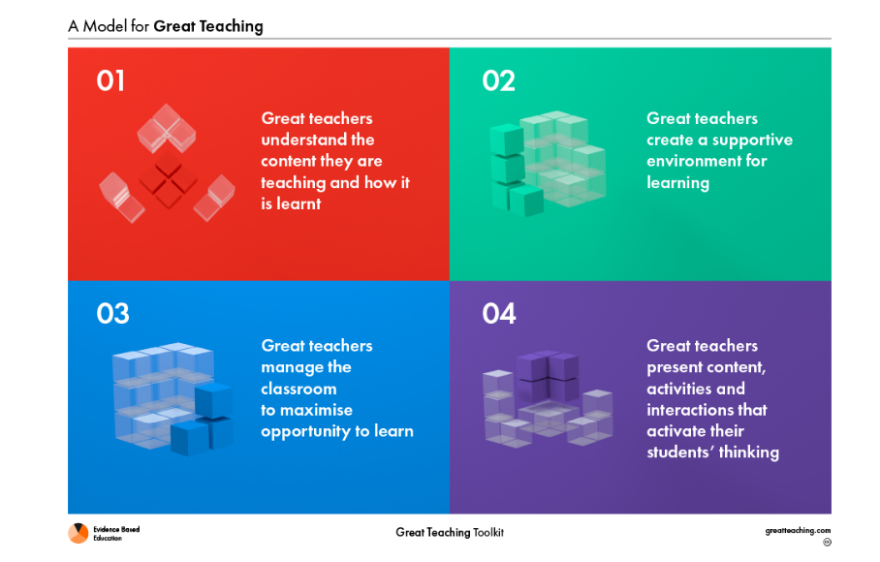
Linked to existing attainment data we are actively involved in programmes to improve overall attainment in Writing. This includes professional reading, reaching stage agreements around priorities, setting ambitious targets and trying some more innovative approaches including those that will bolster other aspects of children’s learning e.g. storytelling for promotion of both narrative skills and listening and talking skills
We also have a focus on the creation and moderation of manageable, High Quality Assessment in Numeracy.

