Longside School
Improving attainment and achievement
Whole School Assessment and Reporting May 2022
This policy sits alongside the authority’s ‘Learning, Teaching and Assessment’ tool launched in March 2022 Learning Teaching and Assessment in Aberdeenshire – A great place to live and work (glowscotland.org.uk). All children should benefit from high quality learning experiences that are based on the following key features:
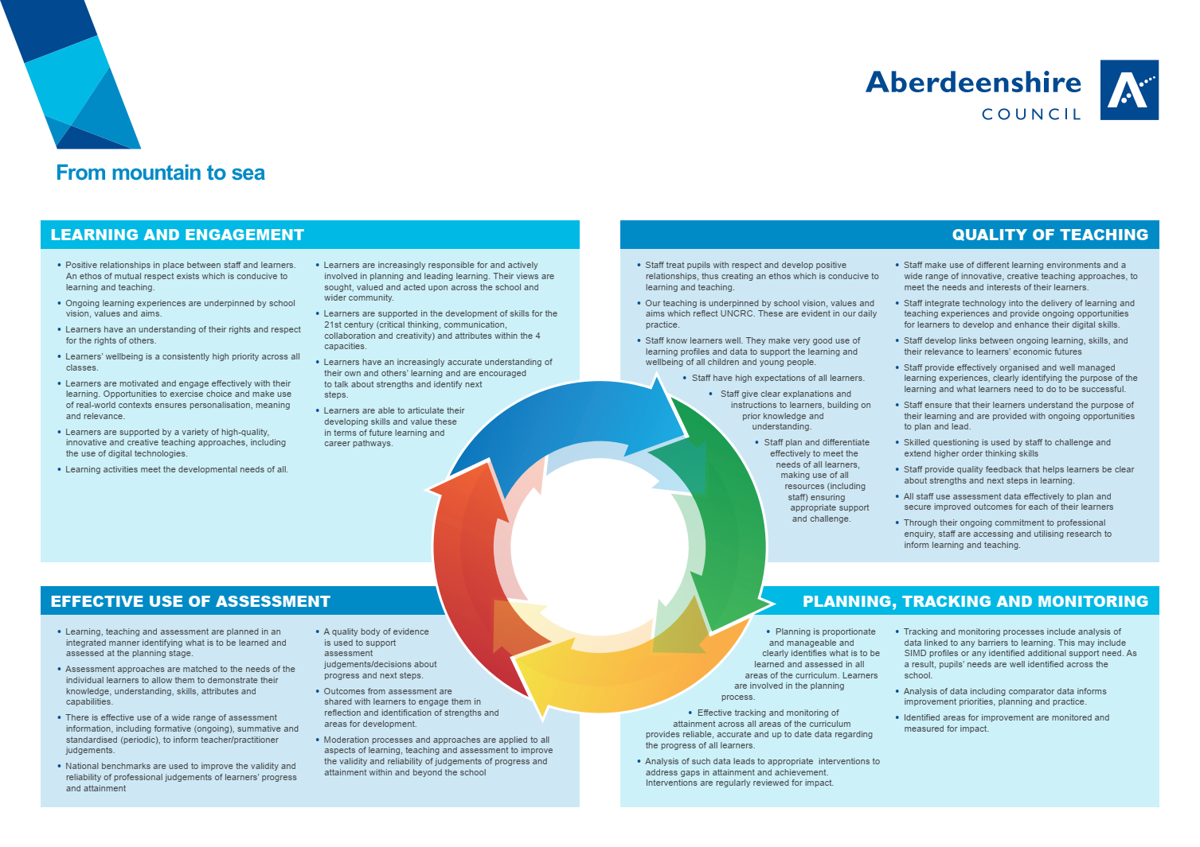

At Longside School our vision is for all our children and the school community to “Learn, Achieve, and Succeed.”
To help promote this and allow our children to succeed in all they do, we have a Curriculum Rationale which encompasses all that we strive to do but which has the children at its centre.
For us to ensure our children are progressing in all areas of their learning, we make use of a wide range of assessment approaches to provide us with reliable and valid evidence which we use to report progress made. This is achieved through teachers’ professional judgement alongside a breadth of manageable and effective assessments.
A combination of both formative and summative assessment approaches are used in school.
- Formative Assessment furthers the learning e.g. How could I improve this? How could I better understand this?
- Summative Assessment determines what has been learnt e.g. I can……. I know that…..
Formative Assessment
In Longside School we use a range of formative assessment approaches daily. Some of these can be used to quickly inform teachers of 3 things-
- How the children feel they are learning
- How confident the children are with what they are learning
- Which children need further support to enable them success in their task and their learning.
Formative approaches in evidence at Longside School include-
Traffic lights | Show me | Peer assessment of story writing | Concept/ mind maps | I wonder.... open ended statements | Teach it to another
Fist of 5 | Thumbs of understanding | Tickled pink/ Green for growth | Circle time | No hands up | Shoulder partners

Formative assessment can also be developed by children and teachers through generating shared learning intentions and negotiating success criteria.
It encourages all children of any ability to-
- access tasks and allows them to take responsibility for their own learning
- make decisions and choices
- feel confident to question, challenge and seek help
- think about and articulate their ideas and opinions
- have a clear understanding of what they are learning
- enable them to improve their own work and boost their self-esteem.
For teachers it allows them to-
- actively involve all children in their own learning
- listen to what pupils say and watch what they do
- use strategies to maximise pupil thinking and articulation
- model quality by using real examples
- focus feedback on success and improvement against learning objectives
In Longside School we use the following strategies-
Effective questioning
Creating/ sharing LI/ SC

We expect all learners to be prepared to participate in their learning and take an active rather than passive role. Strategies such as- Thinking time, No hands up, Lollipop sticks, Learning Walks, Post it notes, Think, Pair, Share, etc allow opportunities for teachers to engage all children in their learning and for pupils to have the opportunity to share their understanding and capabilities.
It is expected teachers will use a variety of AiFL (Assessment is for Learning) strategies as part of their formative assessment for assessment to be relevant, valid, and reliable. It is only then that an accurate picture can be built up of a pupil’s learning.
Effective Feedback
Assessment is only as good as the feedback that we give. Quality feedback is an essential part of purposeful teaching and improving pupils’ learning. When pupils receive high- quality feedback, they have an accurate understanding of their progress in learning and what they need to do to improve and take next steps.
The main problems with feedback which have been identified in research are that our feedback is very often-
- too little
- too late
- too vague
- too impersonal
As a staff we need to consider both the oral and written feedback we give to pupils.
Oral Feedback
- ensuring that it relates to what is being learnt- Teachers share with pupils WHAT they are learning and HOW they will know that they have been successful in that learning (Learning Intentions and Success Criteria)
- avoiding the spot- checks where a high level of closed questioning is used- feedback in these instances can seem less about improvement and more about corrections of mistakes that the teacher has spotted
- using questioning to focus feedback- effective questioning by the teacher ensures that pupils demonstrate their thinking in an answer. The resulting answer provides an insight into the problem and suggests an appropriate next step
- focusing feedback on the task, NOT the pupil- when pupils are experiencing difficulties, teachers should ensure that they focus their feedback on the task coupled with a helpful suggestion on a possible way to approach the problem. In this way, the feedback does not discourage or demotivate the pupil.
- Looking at praise and encouragement- using less praise and more encouragement. Praise often comes at the end of a task, whereas encouragement can be given at any time; Pupils feel as if they must earn praise. Encouragement can be given without any trigger; Praise often makes pupils put a priority on pleasing the teacher. Encouragement accepts them for being themselves; Praise is often vague. Encouragement can be explicit and informative. At Longside School we endeavour to balance praise, encouragement, and appreciation in the classroom to ensure our pupils are motivated and that their self-esteem is allowed to develop positively.
Effective Marking
The main problems in marking which have been identified in research are-
- Too much information in the marking- pupils become confused
- Too little information- just ticks and crosses/ dots and no comments
- Marking which does not give any clear indication of what the pupil must do to improve the work
- Teachers not giving any time for pupils to follow up on the marking.

Written Feedback
- Using more comments marking- moving away from marking which concentrates on grades or marks out of ten to comment marking which gives pupils an idea of how to improve their work
- Focusing the marking- teachers share with pupils WHAT they are learning and HOW they will know they have been successful in that learning (LI/ SC). Teachers are now focusing their marking on these aspects rather than overwhelming pupils with too many corrections
- Planning time to follow up on marking- teachers are making sure that they build in time to the daily planning of work to ensure that pupils can follow up on comments and suggestions to improve their work
- Developing more peer and self-assessment as part of marking- the teacher is not the only person in the class with good ideas on how to improve the work. Pupils are learning how to evaluate their own work and how to identify successes and to suggest strategies to improve their peers’ work. This requires considerable training and support by the teacher.
- Developing opportunities to model good work with the whole class- teachers may mark a piece of work with their whole class, involving the pupils in discussion on how well the work has matched the Success Criteria. The piece of work may have been created by the teacher to highlight certain learning points. Pupils develop the skills of giving feedback and assessing work
- Do less marking away from the pupils (distance marking)- pupils learn best from verbal feedback given soon after the work is completed. Teachers are encouraged to look at the ways in which they can decrease the amount of work that is marked away from pupils where feedback is delayed
- Using interesting and motivating ways of marking- pupils are often discouraged by marking which deface their work with lots of scores, ticks, question marks….Staff at Longside School use a variety of different and innovative ways to motivate and inspire pupils to act on that marking including- Highlights and prompts e.g., Tickled pink and Green for growth; 2 stars and a wish; traffic lights; post it notes; marking codes.

Summative Assessment
Summative assessment is widely used as a means of checking what children have learned. This is often done at the end of a piece of work. Progress will be evidenced using a variety of approaches that best reflect the learning that has taken place and will track the skills that the individual child is developing. Summative assessments also help support our judgements about learner progress.
Assessment is ongoing throughout the Primary School years and is a continuous process which influences the goals set for individual pupils. Summative Assessment in Longside School is done through-

End of unit or chapter tests/ check ups | Benchmark or interim assessments | Authority or National assessments- SNSA (P1, P4 and P7); NGFR; Emerging Literacy screening in P1 | Writing assessments linked to benchmarks (x1/ term)
SHM check ups | PCM reading benchmarking | Periodic spelling checks | Phoneme end of set assessments P1

Staff have completed some initial training on HQA (High Quality Assessment) and retrieval practice in session 2021-22. HQA will remain an improvement priority for the next two academic sessions.
These assessments provide teachers with immediate feedback on each child’s progress at a particular point in time and the results are used to help teachers plan the next steps in learning for each child against authority and national benchmarks.
The information from summative assessments, although important, can only help in evaluating certain aspects of the learning process. It is important that we also consider the information gathered through ongoing formative assessments. In this way, we can ensure we provide our pupils with opportunities to improve their attainment and achievements.
It is acknowledged that further work is required on Benchmark/interim assessments across core curricular areas. Staff will work further on this next session as part of Curriculum Development Time.

Some additional detail about the roles of all categories of staff can be found below:
Leaders of Learning: Support Staff – Learning Teaching and Assessment in Aberdeenshire (glowscotland.org.uk)
Classroom Practitioners – Learning Teaching and Assessment in Aberdeenshire (glowscotland.org.uk)
Leaders of Learning: Senior/Middle Leaders – Learning Teaching and Assessment in Aberdeenshire (glowscotland.org.uk)
The role of the Quality Improvement Officer – Learning Teaching and Assessment in Aberdeenshire (glowscotland.org.uk)

(Saved in Sharepoint/ ECS Longside Staff/ Assessment/ Whole School Assessment Policy)

