Top tips to help your child build their vocabulary
A rich vocabulary allows children to say exactly what they mean. Knowing and using lots
of words helps them to understand what others are saying, to talk and write in an engaging way, and to better understand the world around them.
So……how can we help them learn new words?
Talk to Each Other!

The more talking we do with children at home, the more language and vocabulary they come across.

Encourage conversations about things that interest them, what is going on in their world, and in the world around us.

Try watching a documentary together or listen to the news (BBC Newsround) or point out a newspaper headline and then encourage them to express their opinions and ideas about it.

Even if you disagree, let them speak and show that you appreciate hearing their views!

Read to them/ Share a book

Read them things they enjoy, do the voices, make it interesting, and don’t stop reading to them just because they learn to read for themselves!

Listening to adults read gives children the chance to listen to books that they might not be able to read independently.

It allows children to hear how a skilled reader brings the words on the page to life.

It enables “booktalk” – time to discuss ideas and share opinions about what you’re reading.

It can safeguard some shared time together – time to enjoy a book that you both want to read, a book you now share in common.
Talk at the Table

Talk about food when you’re at the dinner table. Use interesting words to describe what you are eating: “My peas are not just nice and tasty – they are delicious, they are scrumptious!”

Dinnertime is also a good opportunity to ask your child about their day. Remember and share your own day too!

Make plans for the weekend, talk about the clubs they go to, the friends they are meeting up with…

Discover Language on the Go!

When out and about (shopping, walking, cycling or in the car) point out food labels, road signs, shop signs, street names, words on shopping bags…..
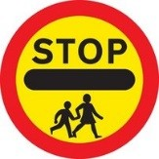
Play Word Games

You could explore synonyms (words that mean the same thing) together. See how many different words your child can think of for nice, pretty, or tall. Some healthy competition with friends or siblings can help to make this fun.

Rhymes

Read rhyming books eg. The Gruffalo, Hairy MacLary, Room on the Broom....

Sing Nursery Rhymes- can they add in the word at the end of each line eg. Jack and Jill went up the ….. Can they invent new words? Eg. Jack and Jill flew up to the moon…

Support your child to create rhyming words (even nonsense words!) eg. I spy with my little eye something that rhymes with bar- car, jar, star, lar, var……

Make up Silly Rhymes

Make up rhymes together eg. Humpty Dumpty drove a fast car
Humpty Dumpty got stuck in the tar!
All the King’s horses and all the King’s men
Pushed him until he was free again!

You are in charge!

Brainstorm ideas for an event or function. Why not give ideas for items and see if your child can rank them in order of importance e.g. the 5 most important things you would need to...... go to the beach, for a birthday party, bake a cake...

Join the Library!

Become a member of the local library- it’s free!
And this way your child can enjoy LOTS of new stories, whether it’s a book or an audiobook!

When you’re playing, talking or reading with your child some of the things you can do to ensure that they have your full attention are:
- Be beside them
- Give them eye-contact
- Turn off your phone/ TV/ computer/ ipad etc.
- Find a quiet space
- Allow them to finish before you talk
  - Show that you’re interested by smiling and nodding

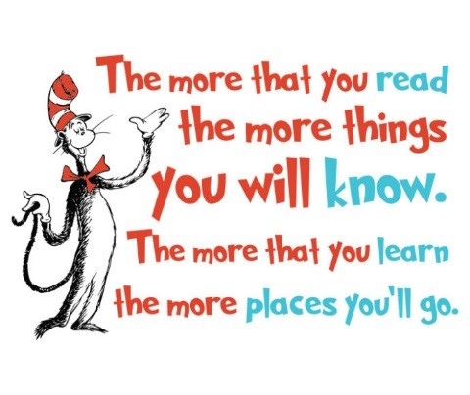

V Willox March 2022
SMT/Mrs Willox/Emerging Literacy/Working with Parents

